Particulate matter with a size under 2.5 micrograms (PM25) is released into the air by woodburning stoves. These particulates are known to cause health issues. These particulates are also sometimes trapped at a low altitude by a phenomenon known as a temperature inversion. When this occurs, the concentration of PM25 increases. This is undesireable and the underlying causes for temperature inversions is being studied.

Below are multiple types of weather data collected over one month in the area of Keene, NH.

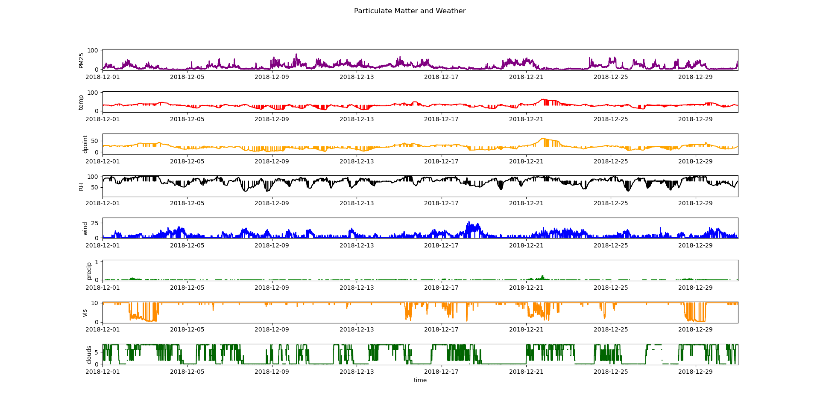

There is a lot going on in these plots though, so let’s see if we can find any values with high correlations to start making sense of things.

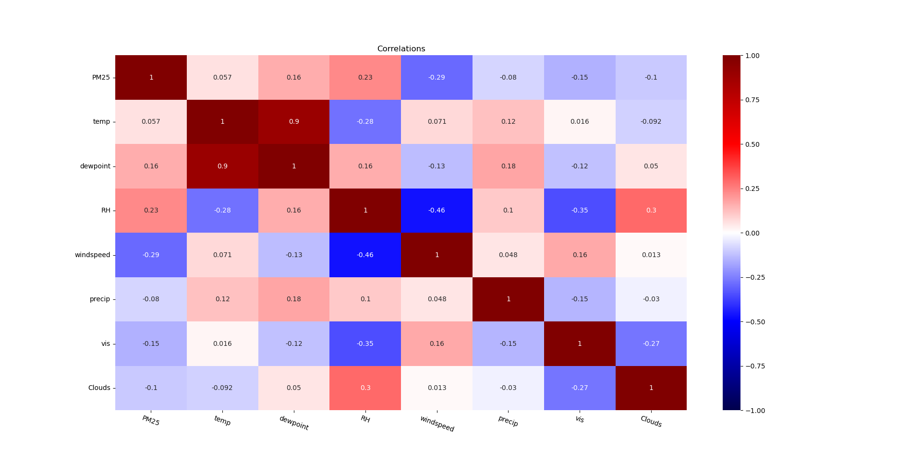

Relative humidity (RH) and windspeed have the highest correlation with PM25 of all the values, although the correlations are not very high. Windspeed has a correlation of -0.29 with PM25, relative humidity has a correlation of 0.23 with PM25. The highest overall correlations between all values is dewpoint and temperature with a value of 0.9, but that does not immediately seem to have any relevance regarding the PM25.

Let’s take a closer look at these correlations.

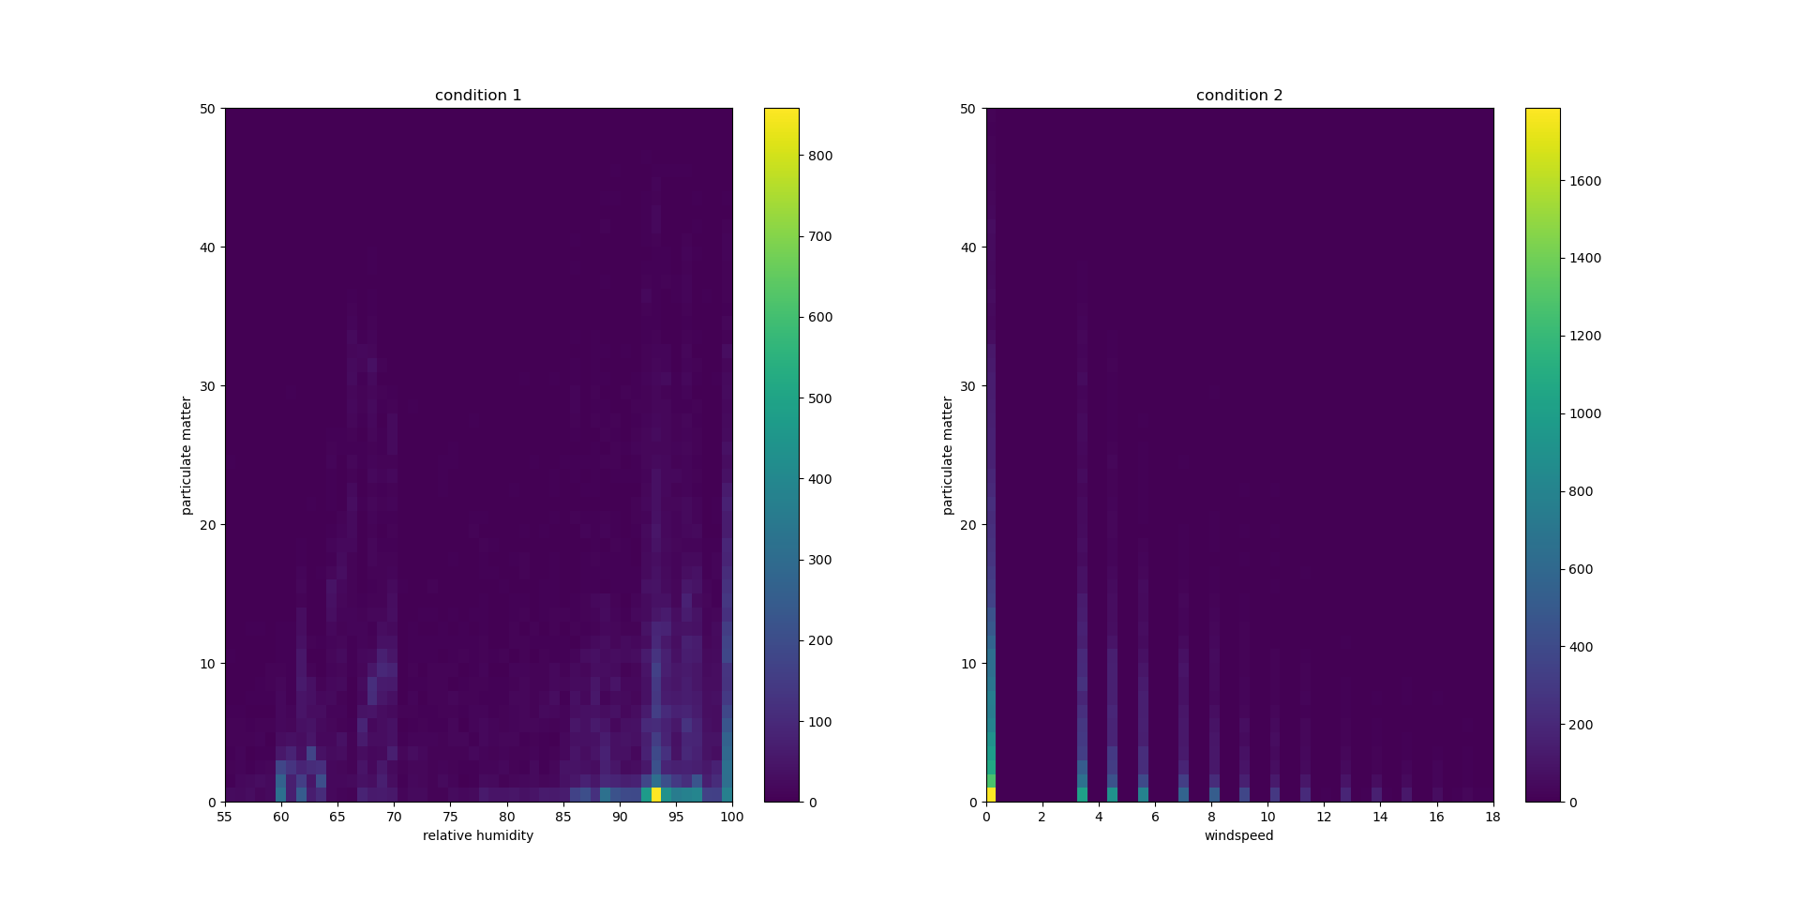

Looking at the plot on the left, high PM25 values occur during both low and high RH, but the highest values occur during RH > 85. This seems to indicate that higher relative humidity creates an environment allowing higher PM25 levels and possibly temperature inversions.

More importantly, looking at the plot on the right, higher values of PM25 seem to only occur under low or no wind conditions (values below 6). This seems to indicate that high winds blow away the particulate matter which reduces the concentration.

Let’s look at this from another angle and plot PM25, windspeed, and relative humidity all together. To make the data easier to read I have calculated the (centered) rolling averages for these values using a zone size of 100. I have also zoomed in so we are only viewing five days of data.

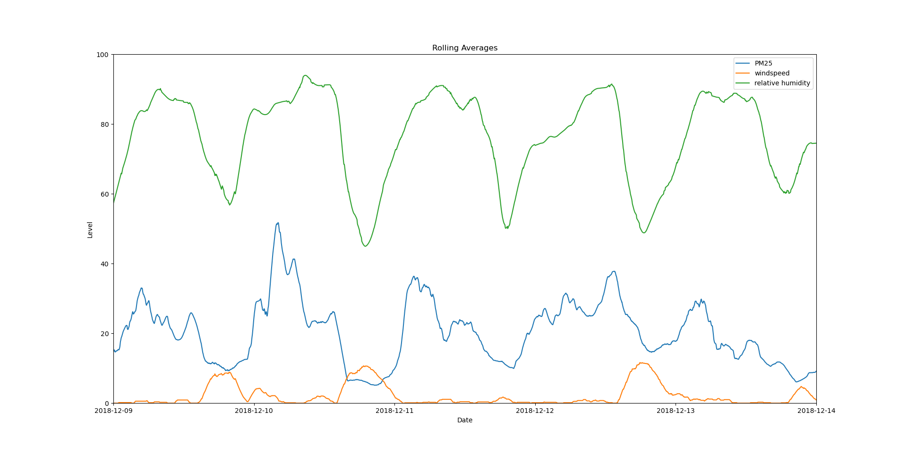

Looking at this plot, when windspeed (orange) increases PM25 (blue) decreases (with a slight exception before 12-12). Additionally the PM25 levels have similar rises and falls as the relative humidity (green). These relationships follow the previously discussed correlations.

In summary, high relative humidity and low windspeed seem to create an environment where higher PM25 levels can occur. If I were to continue this research, my next step would be to analyze the day night cycle that seems to be shown by relative humidity. I would also apply the believed/stated common times for wood burning and temperature inversions to this cycle analysis. Additionally, I would plot all of the values on one plot and see if any other patterns appear. Finally, I would look at the relationship between relative humidity and windspeed as there seems to be a correlation there.